**Student name and surname**: Aneurin Hodgson-Roch

**Student number**: 10519004

**Name of the game**: Whiteboard World

**Target platform**: PC

**Controls**:

Move: Mouse movement

Draw: Mouse button 1

**Tools**:

Management: <https://trello.com/invite/b/3AlFIMdV/f86f3a57af54cf24d4ce9fb47853f78d/aint254-game>

Repo: <https://github.com/aneurinhr/AINT254Project>

**Story**:

The game is set in a whiteboard world, where your escorting a set of green magnets through a puzzle. It is the classic “chicken cross the road” story where you need to keep the magnets alive whilst crossing the maze-like and sometimes dangerous whiteboard environment. The green magnets are some of your followers and as their leader it is your duty to escort them safely. Letting them die will lose you respect from your other followers.

**References/Inspiration**:

**Line Flyer** is a series of games that was a good piece of inspiration. It was such a simple game, with a plain white background. A game where you only drew paths for AI. When I first thought of my game idea of drawing paths, this was one of the first games that really inspired me to go through with it.

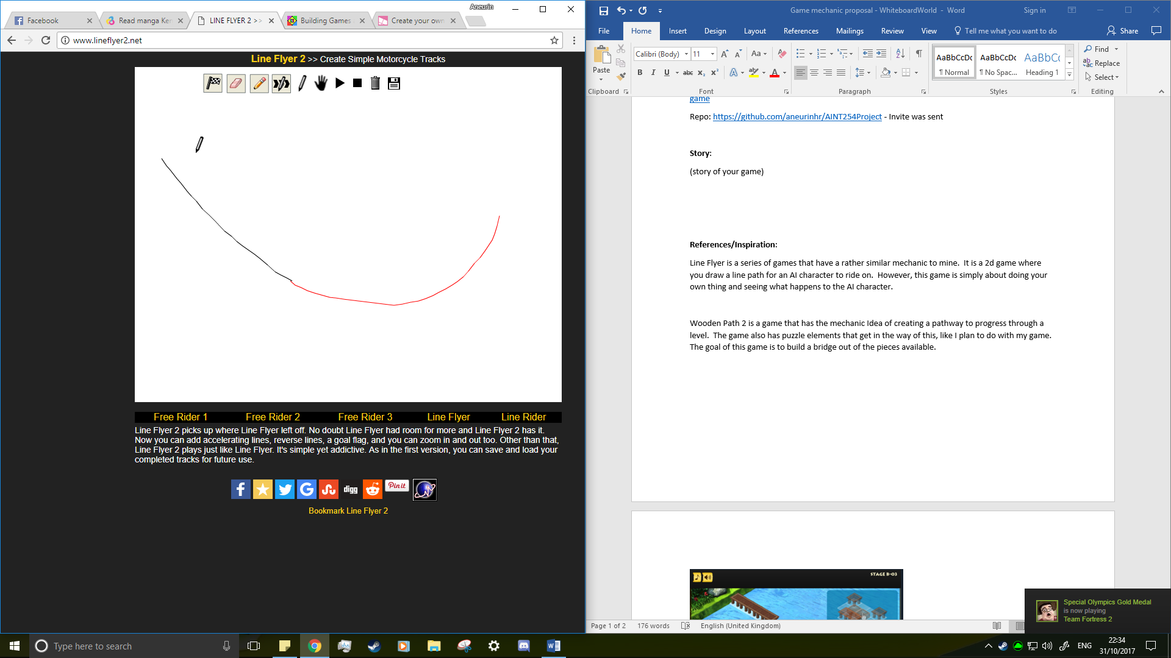

**Wooden Path 2** is another game that inspired my project. I game across it in my search for similar games of my idea. The idea for this is to figure out puzzles, so you can build a bridge, or a path to complete the level. The puzzle element is something I want for my game too.

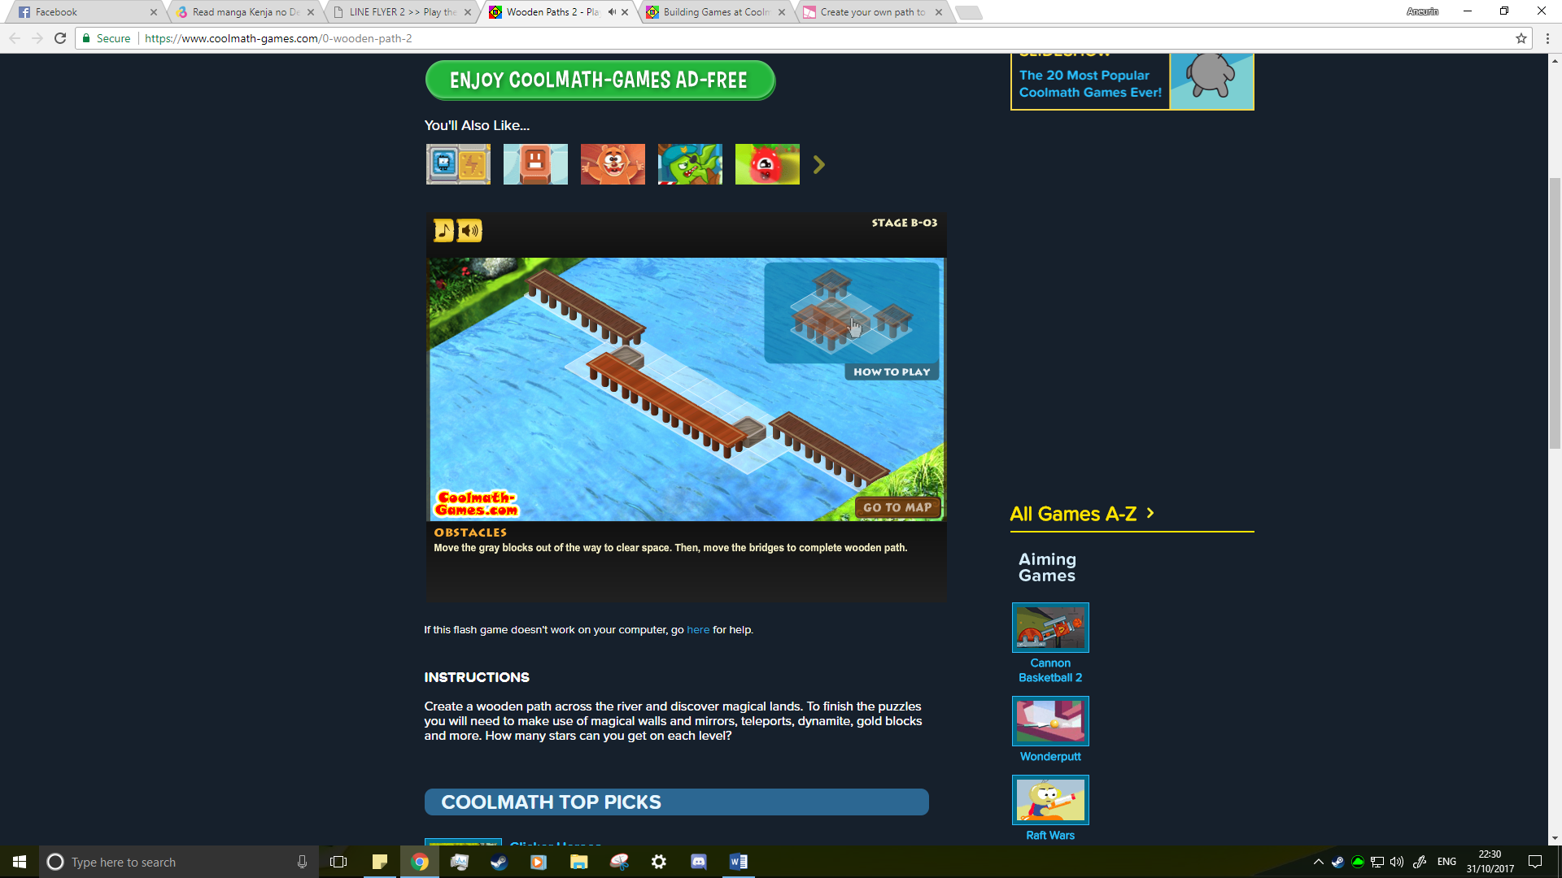

**Draw your way 2** is another puzzle game where you must keep yourself alive. This was a game I also game across during my search. The limited ink was an inspiration for me as it adds an extra level of difficulty to the game. This also has a different form of puzzle. This game was more about keeping yourself alive which gave me the idea of having destructible AI friendlies. In the future, I would like to implement traps that could possibly end you AI life’s. So, you must find a safe and quick route through the puzzles.

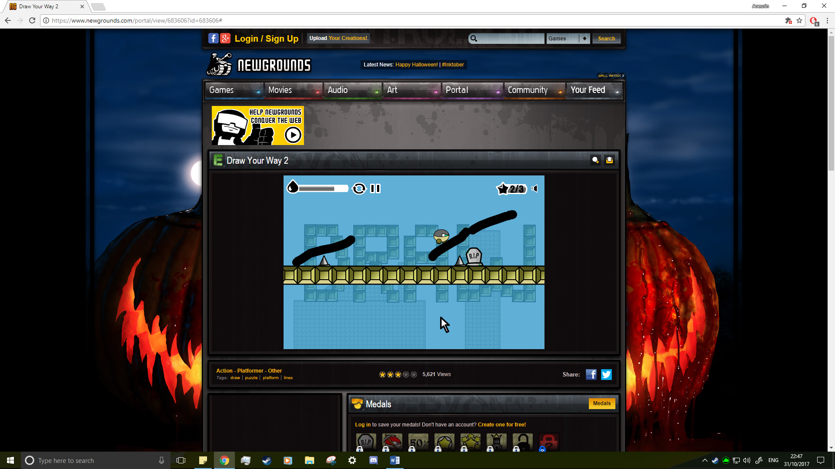

**Aim**:

This is a coogle mind map I created for my future developments on this.

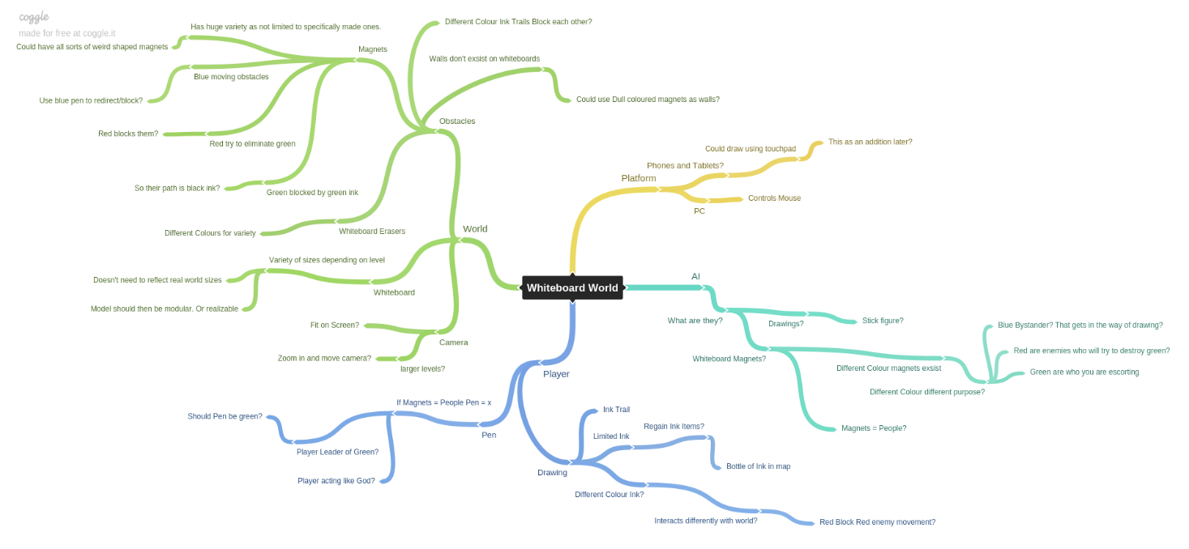

I aim to add more variety into the game. As the game world is a whiteboard, there is somewhat limited environment. However, this can be overcome by using different coloured things. If we give the player the ability to draw in black, green, blue and red ink, we could add some interesting puzzle elements. Such as the addition of enemy or annoying AI that get in your way. These other inks would block the path of the corresponding AI. Green blocks your friendlies, red block enemy AI and blue blocking the path of annoying blue AI. These would of course have their own limited ink supply. I would also introduce them slowly so the player can get used to it.

Not only that, but you would not be able to draw over different colour ink. This would increase the complexity of the puzzles, making the player careful plot they’re plans. Unlike the black ink which acts as a path for the green magnets, the other ink trails can be drawn anywhere on the whiteboard.

These will be done in a very similar way as the black ink that is currently in the demo. Without some of the drawing limitations. Due to you being able to block your own path, I plan to add an esc menu that will pause the game and let restart or quit. This way you won’t be stuck in a game until you run out of ink despite already knowing you’ve blocked your own path.

I also aim to add the ability to control when the green magnets move. Allowing you to pause and start their movement. This is important as it gives the player more control over there green magnets. It also means the player could draw the full line before letting the AI move. However, this could lead to the player having to wait a bit for the AI to follow the path. Due to this I would also like to add in controls for the pace of the game. Allowing you to speed up the time.

Lastly is the scoring. The game won’t feel as rewarding if it doesn’t matter how long you take or how many green magnets survive. Therefore, a scoring system is needed. I would create a scoring system that adds an amount of points for the time left on the clock, multiplied by the number of green magnets that survive. This mean the player has an incentive to quickly complete the level, but to also keep as many magnets alive as possible.